International Student On-Campus Dormitory Information
Campus | Dormitory Building | Room Type | Facilities | Regular Price  (Per Room Per Day in CNY) | International Student Discount Price  (Full Semester Stay)  (Per Room Per Day in CNY) *
Xuhui | Xuesi Garden | Twin Room (Large) | Private bathroom, air conditioning, internet, refrigerator, telephone, TV, desk, storage locker, etc.  Shared kitchen, laundry room. | 225-250 | 140-160
 |  | Twin Room (Small) |  | / | 90
 |  | Single  Room |  |  | 80
Note: The international student discount price is only applicable to students who stay in the school dormitory for the entire semester without changing accommodation during the semester.

Twin Room (Large)
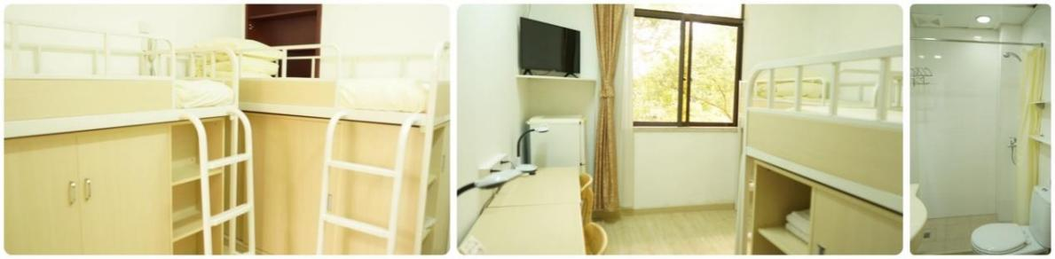

Twin Room (Small)
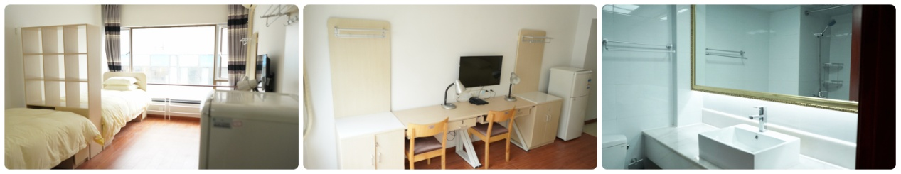

Single Room
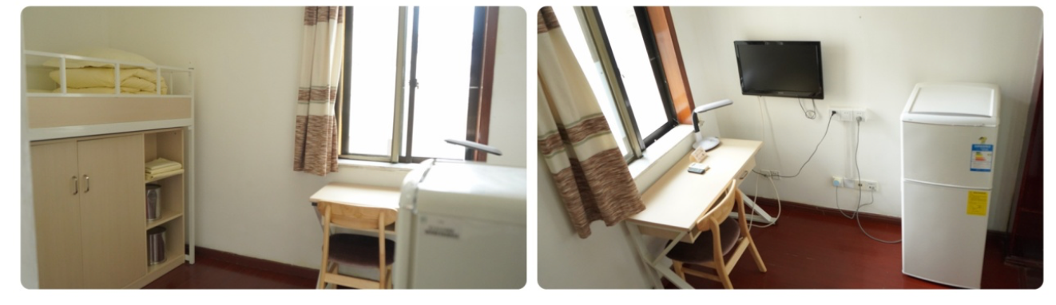

Shared kitchen and laundry room
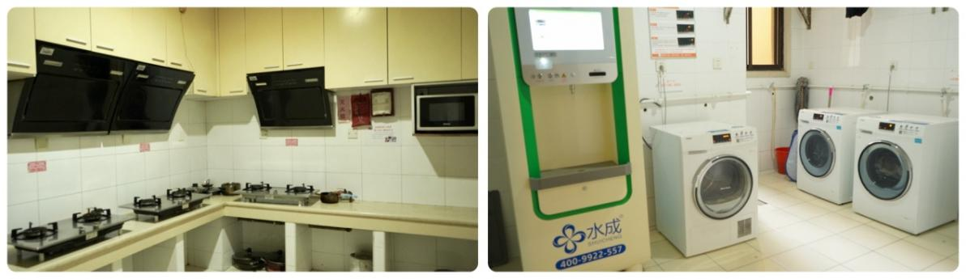

International Student Off-Campus Short-term Hotel Reservation

Yitel Shanghai Xuhui
Location | Room Type | Special Price  (Per Room Per Day in CNY)
No. 124, Caobao Road | Single room | About 400
 | Twin Room | About 400

Link:
https://www.tripadvisor.com/Hotel_Review-g308272-d1050177-Reviews-Yitel_Hotel_Shanghai_Xuhui-Shanghai.html

Single room
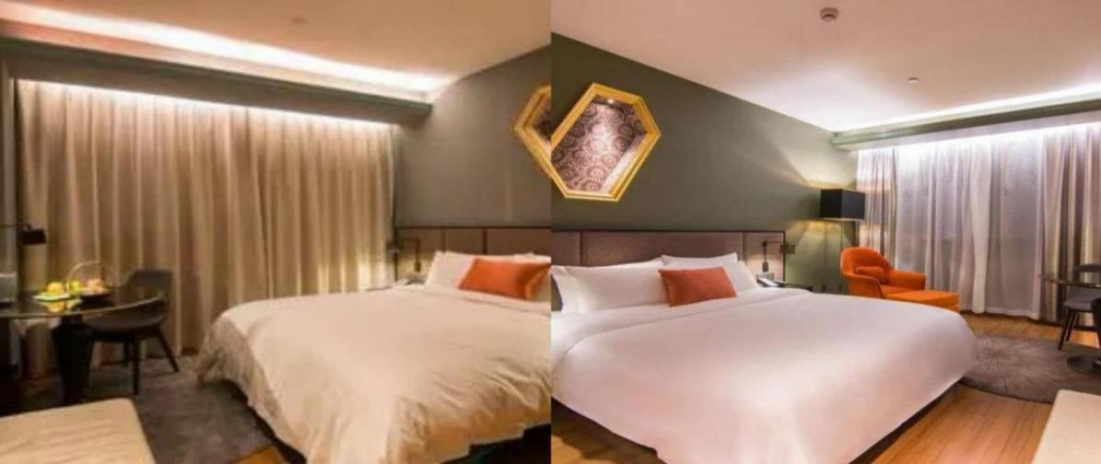

Twin Room
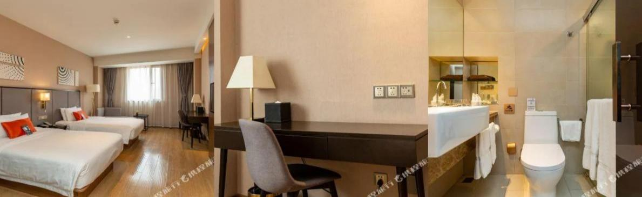

SSAW Boutique Hotel
Location | Room Type | Special Price  (Per Room Per Day in CNY)
1755 North Sichuan Road | Single room | About 450
 | Twin Room | About 450

Link:
https://www.tripadvisor.com/Hotel_Review-g308272-d23163633-Reviews-SSAW_Boutique_Hotel_Shanghai_Xuhui-Shanghai.html

Single room
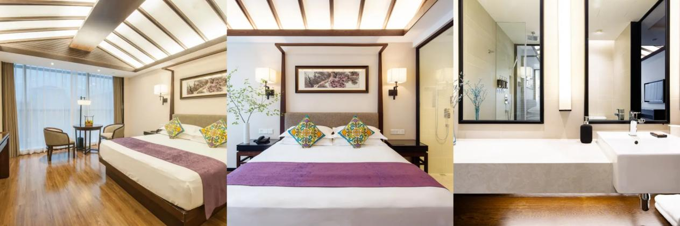

Twin Room
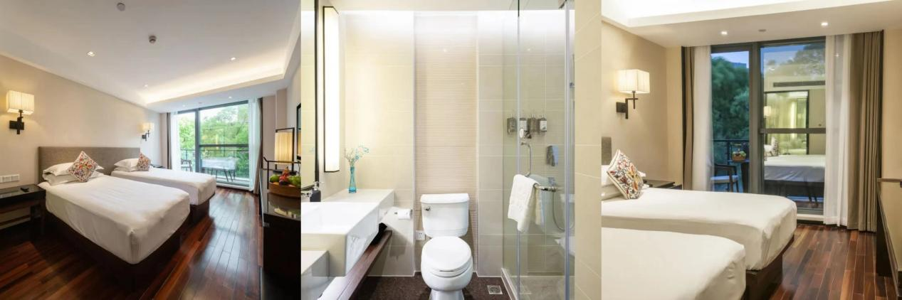

Everbright Exhibition Center Grand Hotel
Location | Room Type | Special Price  (Per Room Per Day in CNY)
66 Caobao Road | Single room | About 400
 | Twin Room | About 450

Link:
https://www.tripadvisor.com/Hotel_Review-g308272-d310962-Reviews-Everbright_Exhibition_Center_Grand_Hotel-Shanghai.html

Single room
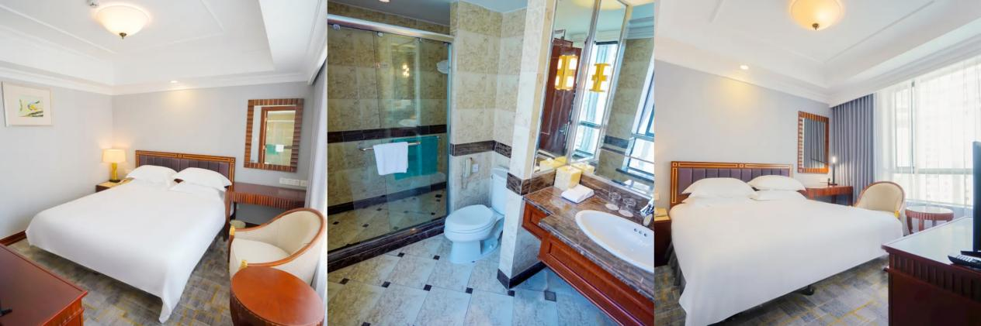

Twin Room
